HireSphere
A PROJECT REPORT
Submitted by

Mahek Tolat
(22CP041)

In partial fulfillment for the award of the degree of
B. TECH. in COMPUTER ENGINEERING

4CP33: Full Semester External Project (FSEP)



BIRLA VISHVAKARMA MAHAVIDYALAYA
(ENGINEERING COLLEGE)
(An Autonomous Institution)
VALLABH VIDYANAGAR

Affiliated to



GUJARAT TECHNOLOGICAL UNIVERSITY, AHMEDABAD

Academic Year: 2025 – 2026
BVM ENGINEERING COLLEGE, VALLABH VIDYANAGAR-388120

APPROVAL SHEET

The project work entitled “HireSphere" carried out by Mahek R Tolat (22CP041) is approved for the submission in the course 4CP33, Full Semester External Project for the partial fulfillment for the award of the degree of B. Tech. in Computer Engineering.

Date:
Place:

Signatures of Examiners:
(Names and Affiliations)

CERTIFICATE

This is to certify that Project Work embodied in this project report titled “HireSphere" was carried out by Mahek R Tolat (22CP041) under the course 4CP33, Full Semester External Project for the partial fulfillment for the award of the degree of B. Tech. in Computer Engineering. Followings are the supervisors at the student:

Date:
Place:

Mr. Dinesh Chauhan | Dr. Bhavesh A Tanawala | Dr. Hemant D Vasava
Node.js Developer  Unikwork Systems LLP,  Surat | Assistant Professor  Computer Engineering Department,  BVM Engineering College | Assistant Professor  Computer Engineering Department,  BVM Engineering College

Dr. Darshak G Thakore
Prof. & Head,
Computer Engineering Department,
BVM Engineering College

COMPUTER ENGINEERING DEPARTMENT, BVM ENGINEERING COLLEGE, VALLABH VIDYANAGAR – 388120

CERTIFICATE

This is to certify that Mahek Tolat (22CP041) of 4th Level, B.Tech. in Computer Engineering of Birla Vishvakarma Mahavidyalaya, Vallabh Vidyanagar has worked on her project under the course (FSEP, 4CP33) titled “HireSphere” under the supervision of Mr. Pavan Golakiya at Unikwork Systems LLP. She has done her work sincerely and has completed her project. We found her work satisfactory.

Place: Surat
Date:

Name and Signature of the External Supervisor
Seal of the company

DECLARATION OF ORIGINALITY

I hereby certify that I am the sole author of this report under the course 4CP33 (Full Semester External Project) and that neither any part thereof nor the whole of the report has been submitted for a degree to any other University or Institution.

I certify that, to the best of my knowledge, the current report does not infringe upon anyone’s copyright nor does it violate any proprietary rights and that any ideas, techniques, quotations or any other material from the work of other people included in my report, published or otherwise, are fully acknowledged in accordance with the standard referencing practices. Furthermore, to the extent that I have included copyrighted material that surpasses the boundary of fair dealing within the meaning of the Indian Copyright (Amendment) Act 2012, I certify that I have obtained a written permission from the copyright owner(s) to include such material(s) in the current report and have included copies of such copyright clearances to the appendix of this report.

I declare that this is a true copy of the report, including any final revisions, as approved by the report review committee.

I have checked the write-up of the present report using an anti-plagiarism database and it is in permissible limit. However, at any time in future, in case of any complaint pertaining to plagiarism, I am the sole responsible person for the same. I also understand that, in case of such complaints of plagiarism, as per the University Grants Commission (UGC) norms, the University can even revoke the degree conferred to the student submitting such a plagiarized report.

Date:
Institute Code: 007
Institute Name: Birla Vishvakarma Mahavidyalaya (BVM) Engineering College

Signature
Mahek Rajeshbhai Tolat
22CP041

ACKNOWLEDGEMENT

I would like to express my sincere gratitude to all those who have supported and guided me throughout the development of this project.
First and foremost, I am deeply thankful to my external project guide, Mr. Dinesh Chauhan, for his continuous encouragement, valuable suggestions, and constructive feedback at every stage of the project. His guidance played a crucial role in shaping my understanding and improving the quality of my work.
I also extend my heartfelt appreciation to my internal project guides, Prof. Narendra M. Patel, Dr. Bhavesh A. Tanawala, and Dr. Hemant D. Vasava, for providing me with the knowledge and guidance required to complete this project successfully. Their academic support has been instrumental in building the foundation for this work.
We also wish to express our deep appreciation to our department faculty members for their constant support and for providing us with the essential knowledge and technical foundation needed for this project.
Our special thanks to our institution, Birla Vishvakarma Mahavidyalaya, for providing us with the necessary facilities, resources, and a conducive environment for learning and innovation.
I would also like to thank my organization and team members for their cooperation, support, and for providing me with a practical environment to apply my skills. Their assistance helped me gain real-world insights and enhanced my learning experience.
I sincerely thank everyone who contributed, directly or indirectly, to the successful completion of this project.

Mahek R Tolat
22CP041

Plagiarism Report

This page will contain the ‘Plagiarism Report’ of This Report.

The plagiarism report must be generated using one of the tools listed below:

Sr. | Name | Website
1 | Viper | https://www.scanmyessay.com
2 | Plagium | http://www.plagium.com
3 | Plagiarisma | http://plagiarisma.net
4 | PlagScan | https://www.plagscan.com/plagiarism-check/
5 | CopyScape | https://www.copyscape.com
6 | Jplag – kit (on github) | https://github.com/jplag/jplag
7 | DupliChecker | https://www.duplichecker.com
8 | DustBall | https://www.dustball.com/cs/plagiarism.checker/
9 | PaperRater | https://www.paperrater.com
10 | Plagiarism Checker | https://plagiarismsoftware.org
11 | WCopyfind | https://plagiarism.bloomfieldmedia.com/software/wcopyfind/

Abstract

The rapid evolution of digital technologies has significantly transformed the recruitment process, making it more efficient, scalable, and accessible. This project, titled Recruitment Management System developed using PostgreSQL, Express.js, React.js, and Node.js. The system is designed to streamline the interaction between job seekers and recruiters through a centralized and user-friendly platform.
Recruitment Management System enables job seekers to create profiles and upload resumes. On the other hand, recruiters can manage applications and shortlist candidates efficiently. The system also includes an HR Admin role, which is responsible for managing and assigning permissions to HR personnel. The HR Admin ensures proper access control, allowing authorized users to perform specific tasks based on their roles within the system.
The system focuses on improving hiring efficiency by reducing manual efforts and enhancing communication between stakeholders. By leveraging modern web technologies, the application ensures scalability, performance, and maintainability.
In addition to the main project, an E-commerce Multi-Vendor Platform was also developed, demonstrating the ability to handle multiple vendors, product listings, and transaction workflows. This further highlights the versatility and practical application of full-stack development skills.
Overall, this project reflects the practical implementation of modern web development concepts and aims to provide a reliable solution for real-world recruitment challenges.

Table of Contents

List of Figures

List of Symbols, Abbreviations and Nomenclature

Abbreviation | Full Form
RMS | Recruitment Management System
API | Application Programming Interface
DB | Database
UI | User Interface
UX | User Experience
HR | Human Resources
JWT | JSON Web Token
REST | Representational State Transfer
CRUD | Create, Read, Update, Delete
HTTP | HyperText Transfer Protocol
HTTPS | HyperText Transfer Protocol Secure
JSON | JavaScript Object Notation
Auth | Authentication
RBAC | Role-Based Access Control
ID | Identifier

1. Introduction
1.1 Overview
The recruitment process has evolved significantly with the advancement of digital technologies. Traditional hiring methods, which relied heavily on manual processes, paperwork, and fragmented communication, are no longer efficient in today’s fast-paced and competitive environment. Organizations require systems that can streamline hiring workflows, reduce manual effort, and improve the overall efficiency of talent acquisition.
The Recruitment Management System is developed as a modern web-based solution to address these challenges. Built using PostgreSQL, Express.js, React.js, and Node.js, the system provides a centralized platform where job seekers, recruiters, and administrators can interact seamlessly. It aims to simplify the recruitment lifecycle, from job posting and application submission to candidate shortlisting and management.
1.2 Motivation
The primary motivation behind developing this project is to overcome the limitations of traditional recruitment systems and provide a more efficient, transparent, and scalable solution.
In many organizations, recruitment processes are still partially manual or rely on multiple disconnected platforms. This leads to inefficiencies such as delayed communication, difficulty in tracking candidates, data redundancy, and lack of proper coordination between HR teams.
Additionally, job seekers often face challenges in managing multiple applications, tracking their status, and finding relevant opportunities in a structured manner.
This project was conceptualized to:
- Digitize and centralize the recruitment process
- Reduce manual workload for HR teams
- Provide a seamless and user-friendly experience for job seekers
- Enable better coordination and communication between stakeholders
- Implement role-based access control through an HR Admin system
1.3 Problem Statement
The existing recruitment systems often suffer from the following issues:
- Lack of centralized data management
- Inefficient tracking of candidate applications
- Limited communication between recruiters and applicants
- Absence of proper role-based access control
- Time-consuming manual processes
These limitations result in delayed hiring decisions, poor candidate experience, and increased operational overhead.
1.4 Proposed Solution
To address these challenges, the HireSphere system provides a comprehensive Recruitment Management System with the following key features:
- Job Seeker Module: Allows users to create profiles and upload resumes
- Recruiter Module: Enables posting job openings, managing applications, and shortlisting candidates
- HR Admin Module: Assigns roles and permissions to HR personnel, ensuring secure and controlled access to system functionalities
- Authentication & Security: Implements secure login and role-based authorization
- Real-Time Data Handling: Ensures up-to-date information across all users
- Responsive Design: Provides seamless access across desktop and mobile devices
The system ensures that each user interacts with the platform based on their assigned role, improving efficiency and maintaining data security.
1.5 Existing System and Limitation
Several online recruitment platforms such as job portals provide basic functionalities like job listings and applications. However, many of these systems lack customization, internal HR workflow management, and proper role-based control.
Traditional systems used within organizations are often:
- Not scalable
- Difficult to maintain
- Lacking modern UI/UX
- Limited in real-time data processing
In contrast, HireSphere is designed as a flexible and scalable system that integrates modern web technologies with efficient workflow management.

1.6 Scope of the Project
The scope of this project includes:
- Designing and developing a full-stack recruitment platform
- Implementing role-based access for Job Seekers, Recruiters, and HR Admin
- Managing job postings, applications, and candidate data
- Providing a responsive and user-friendly interface
Future enhancements may include AI-based candidate recommendations, interview scheduling systems, and analytics dashboards.
1.7 Conclusion
The HireSphere-Recruitment Management System aims to modernize and streamline the recruitment process by leveraging the power of full-stack web development. It provides a structured, efficient, and scalable solution that benefits both job seekers and recruiters while ensuring proper administrative control through the HR Admin role.
This project demonstrates the practical application of modern technologies to solve real-world problems in recruitment and human resource management.

2. Related Work and Background
2.1 Introduction
This chapter presents an analysis of existing recruitment systems and the technological foundation used in the development of the HireSphere. It highlights the limitations of current solutions and justifies the selection of PostgreSQL, React.js, Node.js and Express.js for building a scalable and efficient system. Additionally, it provides an overview of the supporting project developed during the internship to demonstrate practical exposure to full-stack development.
2.2 Existing Systems and Literature Review
HireSphere are widely used to automate and streamline the hiring process. These systems assist organizations in managing job postings, candidate applications, resume screening, and interview scheduling. An RMS is considered a core component of modern HR systems, enabling efficient handling of large volumes of applicant data and improving decision-making processes [1].
Several studies highlight that traditional recruitment methods are time-consuming, resource-intensive, and prone to inefficiencies due to manual data handling and lack of centralized systems. The transition to e-recruitment platforms has significantly improved recruitment efficiency by automating workflows and reducing operational overhead [2].
Existing online recruitment platforms such as LinkedIn, Naukri, and Indeed provide large-scale job listing and application services. These platforms improve accessibility and allow job seekers to explore opportunities globally. However, they are primarily designed for public job marketplaces and often lack customization, internal workflow management, and role-based access control required within organizations.
Research also indicates that many existing recruitment systems are not fully adaptable to different organizational structures, leading to inefficiencies in implementation and usage [3]. Additionally, while modern systems incorporate automation, there are still challenges related to data management, communication gaps, and limited personalization.
Recent advancements in recruitment technologies focus on intelligent systems that improve candidate matching, automate resume screening, and enhance decision-making using data-driven approaches [4]. These systems significantly improve hiring accuracy and reduce the time required for recruitment processes.
Despite these advancements, there remains a gap in developing customizable, scalable, and role-based recruitment management systems tailored to organizational needs. The HireSphere system is proposed to address these limitations by providing a centralized platform with role-based access control, efficient workflow management, and scalable architecture.
2.3 Requirement Analysis
Requirement analysis helps define the system functionalities and characteristics necessary for the proper design and implementation of HireSphere. The system requirements are categorized into functional and non-functional aspects.
2.3.1 Functional Requirements
Requirement | Description
User Authentication | Secure registration and login for job seekers, recruiters, and HR admin
Profile Management | Users can create and update personal and professional details
Job Posting | Recruiters can create, update, and delete job postings
Job Application | Job seekers can apply for available job
Application Tracking | Track status of applications (applied, shortlisted, rejected)
Role-Based Access Control | Different access levels for job seekers, recruiters, and HR admin
Resume Upload | Users can upload and manage resumes
Candidate Shortlisting | Recruiters can shortlist candidates based on criteria
Dashboard Management | Personalized dashboards for different user roles
Data Management | System manages and stores user, job, and application data efficiently

2.3.2 Non-Functional Requirements
Category | Description
Performance | The system should provide fast response time for job search and application processes
Usability | The interface should be user-friendly and accessible across devices
Security | User data and authentication must be securely handled using encryption and validation
Reliability | The system should function consistently without failures during concurrent usage
Scalability | The system should support increasing users and job data over time
Maintainability | Code should be modular and easy to update or extend
Availability | The system should be accessible with minimal downtime

2.4 Technologies Used
The development of the HireSphere is based on a modern full-stack architecture using PostgreSQL, Express.js, React.js, and Node.js. These technologies were selected to ensure scalability, maintainability, and efficient handling of data and user interactions.
Each technology plays a specific role in the system, contributing to a structured and modular architecture. The following subsections describe the technologies used and their relevance to the proposed system.
2.4.1 PostgreSQL
PostgreSQL is an open-source relational database management system known for its robustness, extensibility, and compliance with ACID (Atomicity, Consistency, Isolation, Durability) properties [5]. It supports complex queries, indexing, and data integrity constraints, making it suitable for structured data management.
In this project, PostgreSQL is used to store and manage data related to users, job postings, and applications. The relational nature of PostgreSQL ensures data consistency and supports efficient querying for recruitment workflows.
2.4.2 Node.js
Node.js is a server-side JavaScript runtime environment that enables the execution of JavaScript outside the browser [6]. It is designed for building scalable and high-performance applications using an event-driven, non-blocking I/O model.
In this project, Node.js is used to implement the backend logic, handle client requests, and manage communication with the database. Its asynchronous nature ensures efficient handling of multiple user requests.
2.4.3 Express.js
Express.js is a lightweight web application framework built on Node.js that simplifies the development of server-side applications [7]. It provides features such as routing, middleware support, and request handling.
In this project, Express.js is used to develop RESTful APIs that facilitate communication between the frontend and backend components. It helps in structuring the application and managing different endpoints efficiently.
2.4.4 React.js
React.js is a JavaScript library used for building dynamic and interactive UI through reusable components [8]. It utilizes a virtual DOM to improve rendering performance and enhance UX.
In this system, React.js is used to develop the frontend interface, enabling users to interact with the application in a responsive and intuitive manner. It supports component-based architecture, making the application modular and maintainable.
2.4.5 RESTful APIs
RESTful APIs are used to enable communication between the client and server using standard HTTP methods such as GET, POST, PUT, and DELETE [9]. They follow a stateless architecture, ensuring scalability and simplicity in system design.
The system uses RESTful APIs to handle data exchange between the frontend and backend, ensuring structured and efficient communication.
2.4.6 Authentication and Authorization
Authentication and authorization mechanisms are implemented to ensure secure access to the system. Authentication verifies the identity of users, while authorization controls access to different functionalities based on roles.
The system implements RBAC, allowing different levels of access for job seekers, recruiters, and HR administrators. Secure authentication mechanisms are used to protect user data and system resources.
2.5 System Architecture Overview
The HireSphere follows a client-server architecture. The frontend is developed using React.js, which interacts with the backend through RESTful APIs. The backend, built using Node.js and Express.js, processes user requests and communicates with the PostgreSQL database for data storage and retrieval.
This architecture ensures separation of concerns, where the presentation layer, business logic, and data layer operate independently. Such a design improves scalability, maintainability, and performance of the system.
The overall system architecture is illustrated in Figure 2.1.

3. Modeling and Design
3.1 Introduction
This chapter describes the modeling and design aspects of the HireSphere. It presents the structural and logical design of the system based on the requirements identified in Chapter 2. The design focuses on defining system components, data flow, and database structure to ensure scalability, maintainability, and efficient performance.
3.2 System Design Overview
The system follows a modular client-server architecture. The frontend is developed using React.js, which provides an interactive UI for job seekers, recruiters, and administrators. The backend is implemented using Node.js and Express.js, which handle business logic and API processing. PostgreSQL is used as the relational database for storing and managing system data.
The system is designed with a clear separation of concerns, ensuring that the presentation layer, application logic, and data layer operate independently. This modular design improves system scalability, maintainability, and ease of future enhancements.
3.3 Entity Relationship Diagram
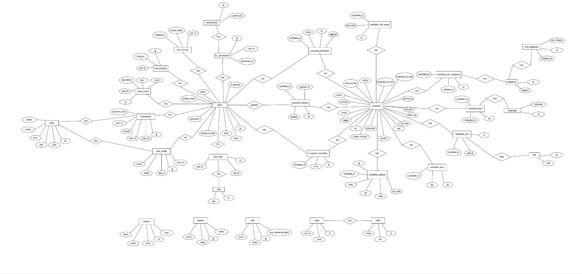
3.4 Use Case Diagram

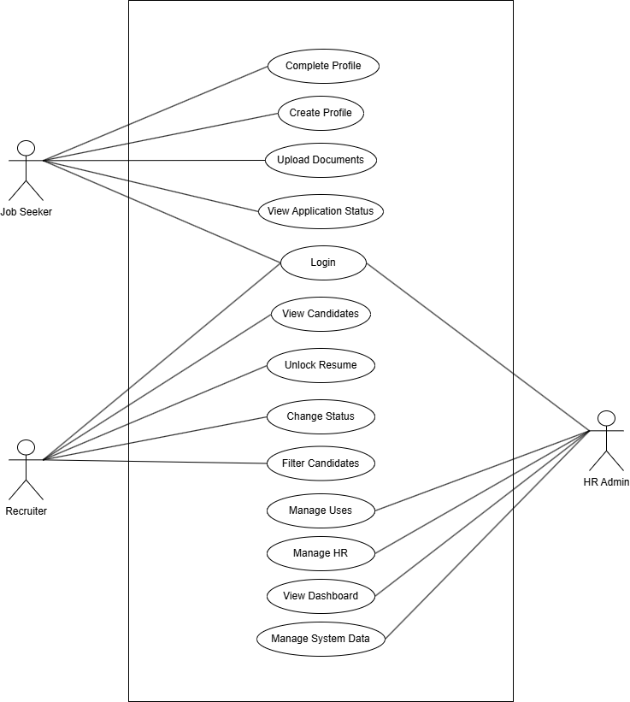
3.5 DFD Level 0
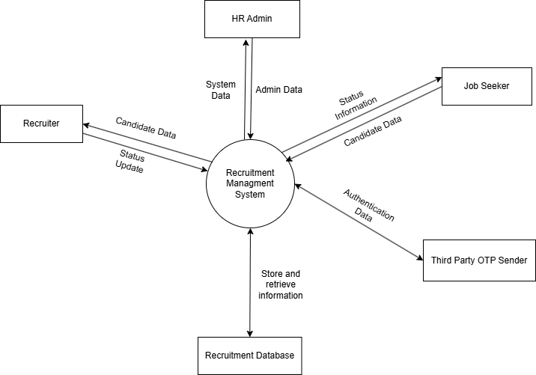
3.6 DFD Level 1
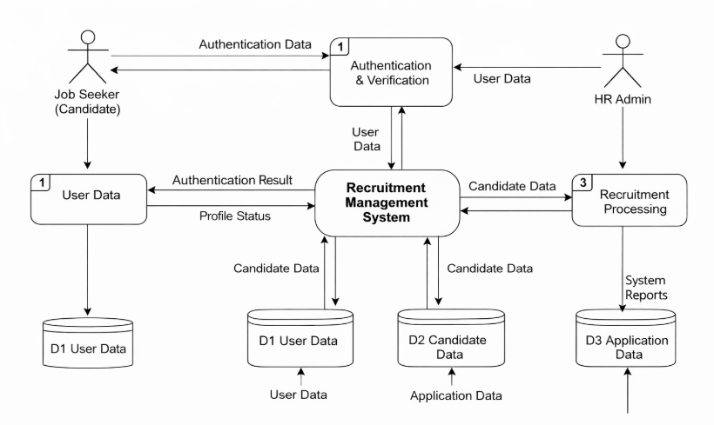

4. Implementation
4.1 Introduction
This chapter presents the implementation details of the Recruitment Management System. It explains the system architecture, module-wise functionality, and workflow of the application. The implementation demonstrates how different components interact to provide a scalable and efficient recruitment platform.
4.2 System Architecture Implementation
The system is implemented using a modular full-stack architecture consisting of a frontend and backend application.
The frontend is developed using React.js, while the backend is built using Node.js and Express.js. The frontend communicates with the backend through RESTful APIs using a centralized HTTP client. User interactions from the interface are processed through API calls, which are handled by backend controllers. These controllers validate requests, execute database operations using Sequelize ORM, and return standardized responses.
The backend follows a structured flow where incoming requests pass through middleware, authentication, and validation layers before interacting with the database. The response is then sent back to the frontend, where the UI is updated dynamically.
4.3 System Workflow
The system workflow is designed to ensure smooth interaction between users and system components.
The process begins with user interaction through the frontend interface. Based on user actions, API requests are sent to the backend server. The backend processes these requests through defined routes and controllers, validates input data, and performs necessary operations on the database.
For example, during candidate registration, the system follows a multi-step process where user data is collected, validated, and stored. Additional information such as documents and profile details are processed through separate API calls to ensure modular handling of data.
The system ensures real-time updates by reflecting changes in the user UI immediately after successful API responses.
4.4 Module-wise Implementation
4.4.1 Authentication
The authentication module manages user login and verification processes. It includes functionalities such as OTP-based verification and secure session handling.
Users are authenticated through API endpoints, and access tokens are generated to maintain session integrity. The module ensures that only authorized users can access system functionalities.
4.4.2 Candidate Management Module
The candidate management module handles the complete lifecycle of candidate data. It includes functionalities such as candidate registration, profile updates, document uploads, and application tracking.
The registration process is implemented as a multi-step workflow where basic information is collected initially, followed by document upload and profile completion. The system ensures proper validation and structured storage of candidate data across multiple related tables.
The module also supports filtering, assignment of candidates to HR personnel, and status tracking throughout the recruitment process.
4.4.3 Recruiter and HR Module
The recruiter and HR module enables management of candidates and system users. It includes functionalities such as assigning candidates to HR personnel, managing permissions, and tracking candidate progress.
The system implements RBAC, ensuring that each user interacts with the system according to their assigned role.
4.4.4 Administrative Module
The administrative module provides system-level control, including user management, configuration management, and monitoring functionalities.
It allows administrators to manage system data such as categories, locations, and reviews, ensuring flexibility and customization of the platform.
4.4.5 Payment and Transaction Module
The system includes a payment module to handle transactions related to service plans. It supports order creation and payment verification processes.
The module ensures secure transaction handling and maintains a record of transaction history for users.
4.5 API Design and Integration
The system uses RESTful APIs for communication between the frontend and backend. All API endpoints follow a standardized structure and are organized based on functional modules such as authentication, candidate management, user management, and payment processing.
Each API response follows a consistent format, ensuring predictable communication and easier error handling. The integration ensures efficient data exchange and seamless interaction between system components.
4.6 User Interface Implementation
The user interface is developed using React.js and is designed to provide a responsive and user-friendly experience. It includes multiple views tailored to different user roles such as job seekers, recruiters, and administrators.
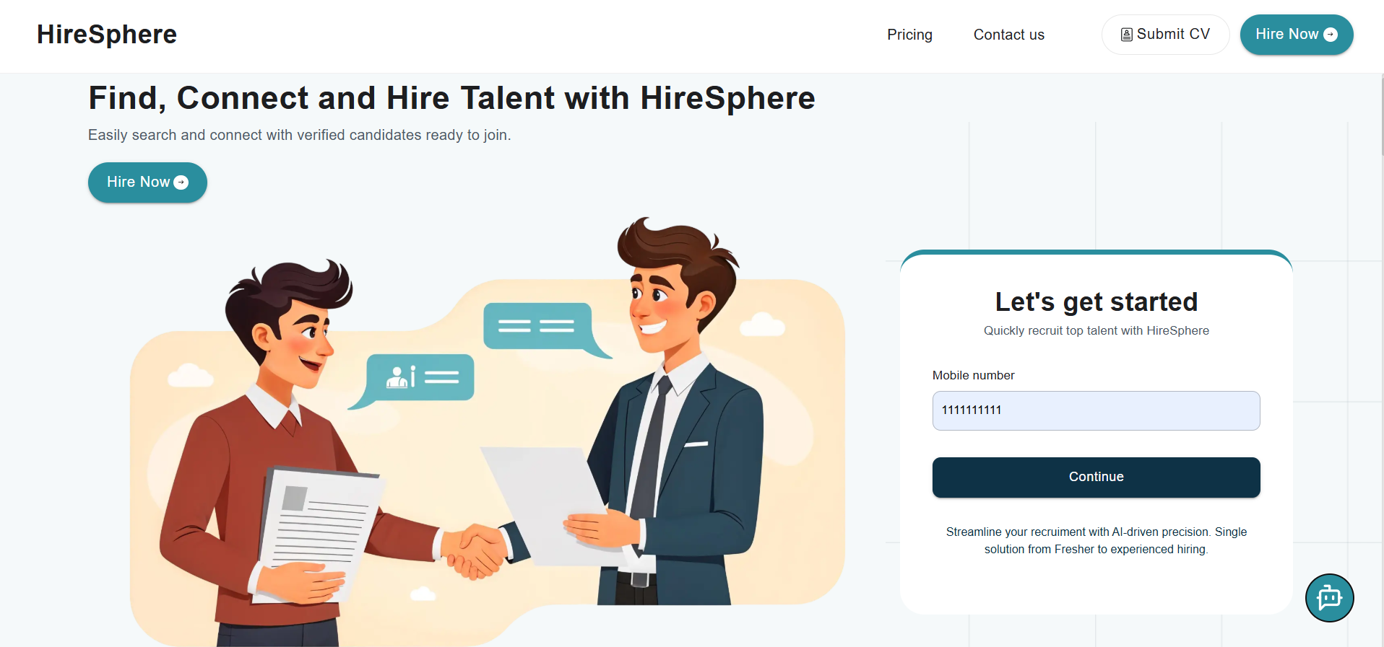
The interface uses modular components and efficient state management to ensure smooth navigation and interaction across the application.

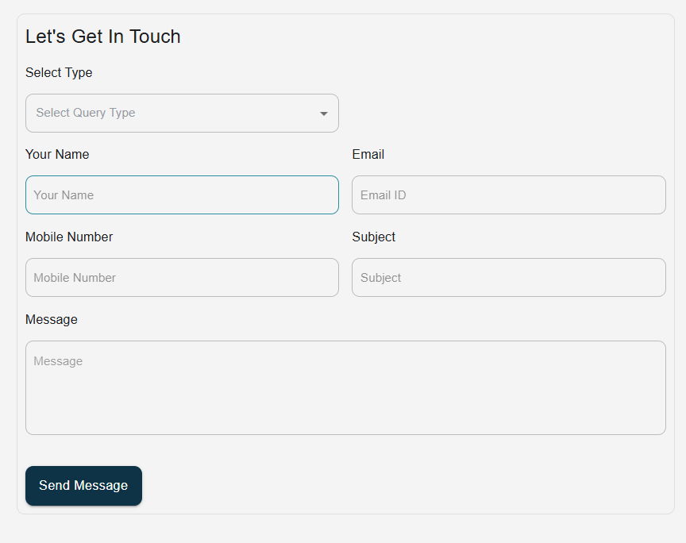

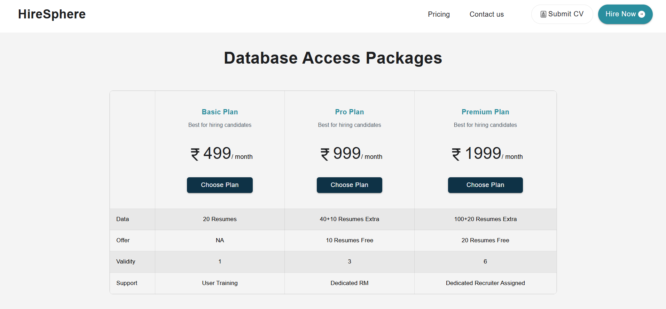
4.7 Result and Output
The system was successfully implemented and tested across different modules. All functionalities, including candidate registration, job management, and role-based access, operate as expected.
The application demonstrates efficient handling of recruitment workflows and provides real-time updates to users. The results validate the effectiveness and reliability of the system.

5. Conclusion
5.1 Conclusion
The Recruitment Management System was successfully designed and implemented to address the limitations of traditional recruitment processes. The system provides a centralized platform that enables efficient interaction between job seekers, recruiters, and administrators.
The application integrates key functionalities such as user authentication, candidate registration, job management, application tracking, and role-based access control. The modular architecture and structured data management ensure that the system is scalable, maintainable, and efficient.
The implementation of the system using PostgreSQL, Express.js, React.js, and Node.js demonstrates the practical application of full-stack development concepts in solving real-world problems. The system was tested across different modules and was found to function as expected, providing reliable performance and smooth workflow execution.
This project provided valuable hands-on experience in designing and developing a complete web-based system. It also enhanced understanding of system architecture, database design, API development, and user interface implementation.
Overall, the system successfully fulfills its intended objectives and serves as a functional solution for managing recruitment processes in an organized and efficient manner.

6. Supplementary Work and Learning Outcomes
6.1 Introduction
During the development period, in addition to the Recruitment Management System, a Multi-Vendor E-commerce Platform was developed as part of practical learning and skill enhancement.
6.2 System Description
The platform supports multiple vendors operating within a single system. Each vendor can manage products, pricing, and orders independently. The system includes functionalities such as product listing, vendor dashboards, and order processing.
The implementation focuses on handling multiple user roles, managing relational data, and ensuring proper workflow between vendors and customers.
6.3 Learning Outcomes
The development of this platform provided valuable insights into:
- Multi-user system design
- Role-based access control
- Database relationship management
- Transaction handling and workflow design
This experience contributed to improved system design decisions in project.
6.4 User Interface Snapshots
(Add screenshots here with proper captions)
6.5 Conclusion
This supplementary work demonstrates the ability to apply full-stack development skills across different domains and reinforces practical understanding of scalable system design.

References:
[1] S. Patil et al., “Recruitment Management System,” IRJET, vol. 9, no. 12, 2022.
[2] M. I. Junejo and M. A. Khowaja, “E-Recruitment and Its Impact on Human Resource Systems,” Int. Journal of Economics, Business and Management Research, 2019.
[3] S. Vishwasrao et al., “A Review on Training and Placement Management System,” IRJET, vol. 9, no. 11, 2022.
[4] “A Review of Online Job Portals: Innovations, Challenges and Future Directions,” IJCRT, vol. 13, issue 4, 2025.
[5] Postman: https://www.postman.com/
[6] Express: https://expressjs.com/
[7] Eraser: https://www.eraser.io/
[8] GitHub:https://github.com/
[9] React: https://react.dev/
[10] Node.js: https://nodejs.org/
[11] PostgreSQL: https://www.postgresql.org/
[12] Tailwind CSS: https://tailwindcss.com/
[13] JWT (JSON Web Tokens): https://jwt.io/

<Remaining report contains all chapters in sequence, as suggested* below… Each chapter will have Sections, (Sub-sections, sub-sub-sections – preferably not more than 3 levels).>

Chapter Number | (Suggested) Chapter Title | Possible Contents
(Not Numbered) | Abstract | One (or maximum 1.5) page abstract about your project
1 | Introduction | Introduction to your project work. This chapter will include motivation behind your project, and may include discussions on other existing solutions and how your approach differs from them.
2 | Related Work and Background | Requirement Analysis, literature survey (if applicable), brief about various technologies used in implementing this project work. Include citations to the books / papers / other materials / websites you might have referred while studying this technology.
3 | Modeling and Design | Different diagrams (use case, DFDs, ER, etc, as applicable - as studied in the software engineering course), Your design approaches or key design thinking that has undergone while developing this project, including database design.
4 | Implementation | Module wise descriptions, including user interfaces (if applicable), results, different use cases showing the work flow / usage of the complete solution. Note that, any sort of source code is not expected in this chapter or at any other place in this report. If you feel that some particular snippet of code is worth discussing, you may include the respective pseudo-code for that purpose.  Note: You are going to submit the video of the working project to your guides / in the department anyway.
5 | Conclusions and Future Scope | Conclusive discussions – including the limitations of your solutions (if any). You may also pin-point to some feasible future extensions possible.
(Not Numbered) | References | Numbered list of references in IEEE standard format.

* Above table shows suggested ‘Chapter Names’ and depending upon the type of work, this structure may change.

Further note that...

- All normal text needs to be in Times New Roman fonts of size 12 pt.

- Avoid unnecessary capitalization in your text.

- Each Figure must have a caption and it should be at the bottom of the Figure.

  - Ensure that the figures are not blurred and the text within the figures (if any) is also clearly legible.

- Each Table must have a caption and it should be at the top of the Table.

- Each Figure and each Table must be referred to at least at one place within the main text.

- If there is any work, (e.g., a definition, a quotation, a Figure, a Table, some pseudo-code, etc.) that is adopted or copied from somewhere / someone (even if it is allowed by that person / organization), the same must be duly and appropriately acknowledged.

References:

(This will be the last (non-numbered) chapter after the “Conclusions and Future Scope” chapter. It contains a numbered list of references that are cited in the main text earlier in this report. It must follow IEEE standard format.)
- First Reference
- Second Reference
- Third Reference
- ...
Note about citing references: Each referred citation here must have been referred at least once in the main text of the document earlier, in square brackets. If multiple references are being cited, they should be comma separated in a square bracket. For example…

This is an example showing how to cite references. Here, I cite the reference number [1]. This second statement cites two other references as [2,3]. Your reference section should have the reference 1, 2, and 3 as dictated / referred above.

